
AMERICAN INTERNATIONAL UNIVERSITY-BANGLADESH
Faculty of Science and Technology
Department of Computer Science
CSC 3215: Web Technologies

Semester: Summer 2025-26 | Group No:7 |  | Section:O

Group Members:
SL. | Student ID | Name | Role | Signature
1 | 23-51668-2 | MD. HASIBUL HAQUE | Group Leader
2 | 23-51644-2 | NOORUZZAMAN CHOWDHURY | Member
3 | 23-51622-2 | SHIAM SHAJIB | Member
4 |  |  | Member
Project Title
SmartFarm: A Web Based Farm Management and Farmer-to-Buyer Marketplace System
Short Description
SmartFarm is a comprehensive web-based farm management system designed to digitize and streamline agricultural operations for modern farms. The platform connects farm administrators, managers, field workers, and customers through a unified interface that handles crop planning, inventory tracking, task management, financial reporting, and direct-to-consumer sales. Built using HTML, CSS, JavaScript, PHP (or Node.js), and MySQL, the system replaces manual record-keeping with real-time data access, enabling data-driven decision-making, reducing operational waste, and improving farm productivity and profitability.
Introduction
Agriculture remains the backbone of Bangladesh's economy, employing nearly 40% of the workforce and contributing significantly to GDP. However, most farms still rely on traditional, paper-based management methods that are error-prone, time-consuming, and lack analytical insight. As farm sizes grow and consumer demand for traceability increases, there is a pressing need for digital solutions that can manage complex agricultural workflows efficiently.
SmartFarm addresses this gap by providing a centralized digital platform where all stakeholders administrators, farm managers, field workers, and customers can interact with farm data in real time. The system enables managers to plan crop cycles, assign tasks to workers, monitor inventory levels, and track financial performance from a single dashboard. Field workers can receive daily assignments, report crop conditions with photographic evidence, and log their attendance digitally. Customers can browse available produce, place orders, and track deliveries without intermediaries.
This project leverages core web technologies including HTML5, CSS3, JavaScript (with optional frameworks like React or Vue), a backend language (PHP or Node.js/Express), and MySQL as the relational database. The system is designed to be responsive, ensuring accessibility from both desktop computers in farm offices and mobile devices used by workers in the field.
Background Study
Farm management software has evolved significantly over the past decade. According to recent industry analysis, modern farm management platforms must integrate financial tracking, inventory control, workforce management, and customer relationship features to remain competitive. Key capabilities include crop planning, harvest tracking, equipment maintenance scheduling, expense tracking, and role-based access for multi-user collaboration.
Existing solutions such as SmartFarmPilot, Farmbrite, and Local Line demonstrate the market demand for integrated platforms, but many are subscription-based, cloud-locked, or not tailored to the specific agricultural context and cost constraints of small-to-medium farms in Bangladesh. Furthermore, most platforms either focus exclusively on back-office operations or on e-commerce, rarely bridging both into a single affordable system.
SmartFarm differentiates itself by:
Offering a self-hosted, open-architecture solution suitable for local deployment.
Combining operational management (crops, inventory, tasks) with direct sales (customer orders) on one platform.
Providing role-based dashboards ensuring each user type sees only relevant functionality.
Supporting offline-capable mobile access for field workers in areas with intermittent connectivity.
Research on database design for agricultural systems identifies core entities including Farmer/Farm, Crop, Equipment, Inventory, and Finance, with relationships that must capture the many-to-many associations between crops and orders, and between tasks and inventory consumption. This project adopts a normalized relational schema to ensure data integrity and scalability.

ER Diagram
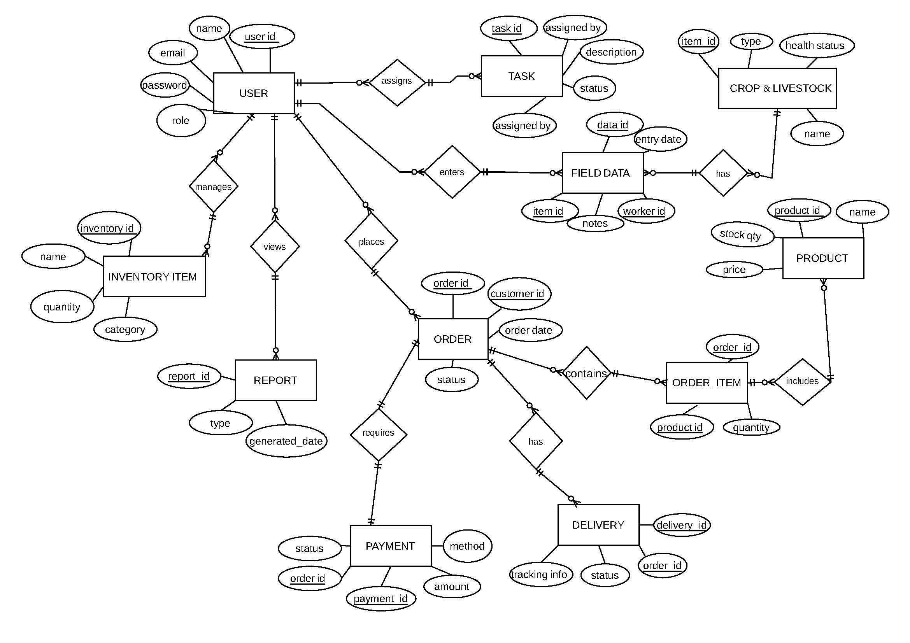
Figure 1: Entity-Relationship Diagram of the AgriTrack Farm Management System

Use Case Diagram
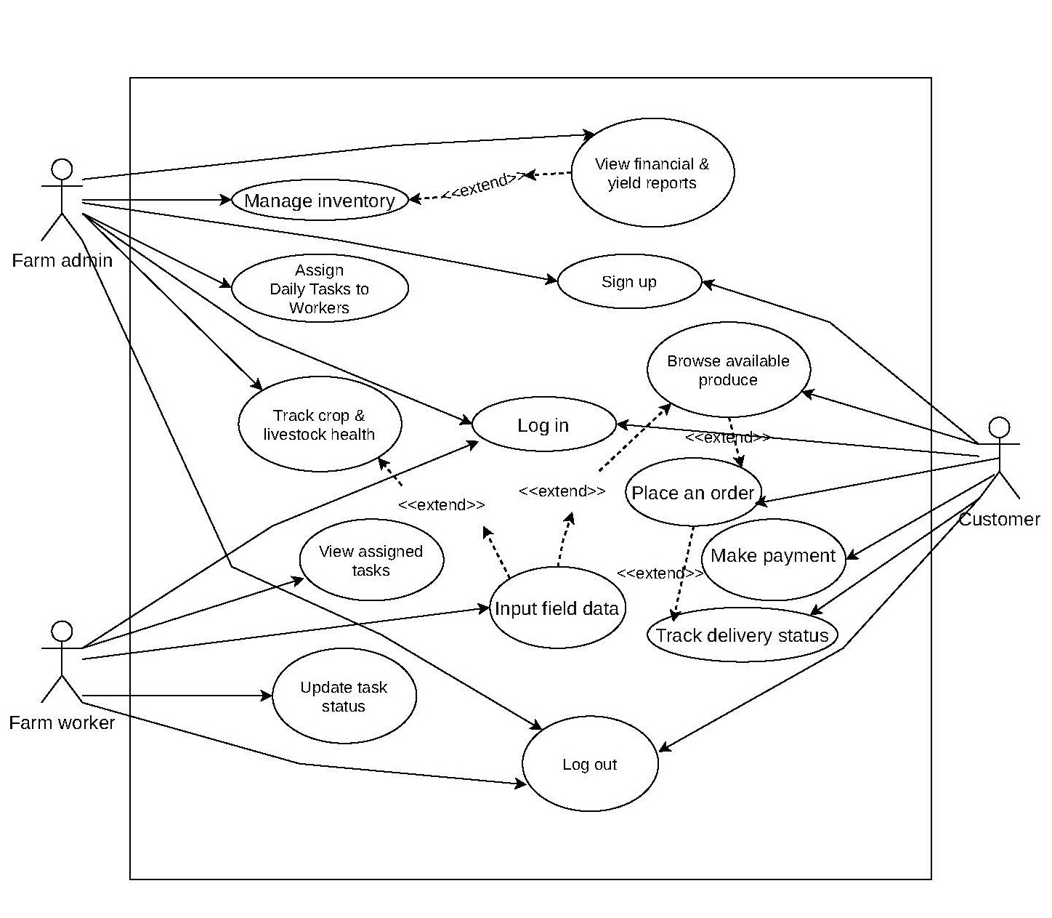
Figure 2: Use Case Diagram showing Farmer, Buyer, and Admin interactions

UI
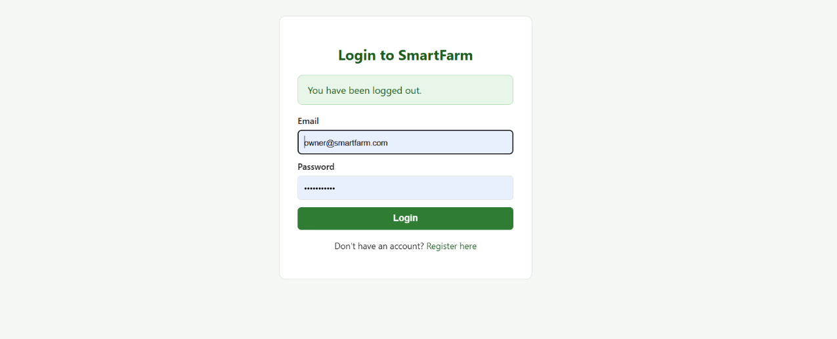
Fig 1: login interface
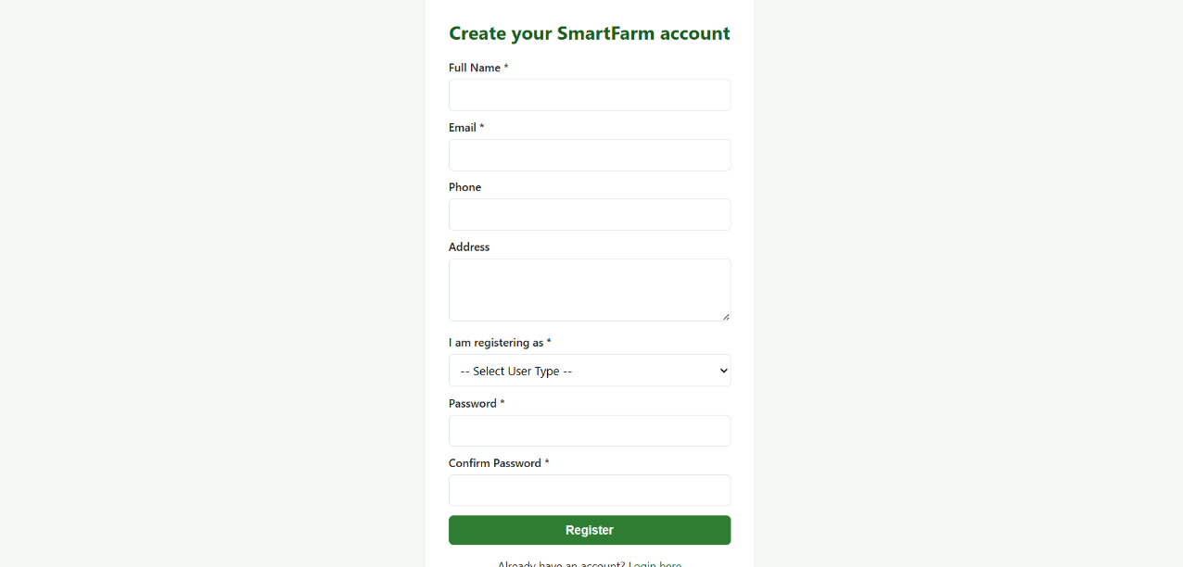
Fig 2: Registration
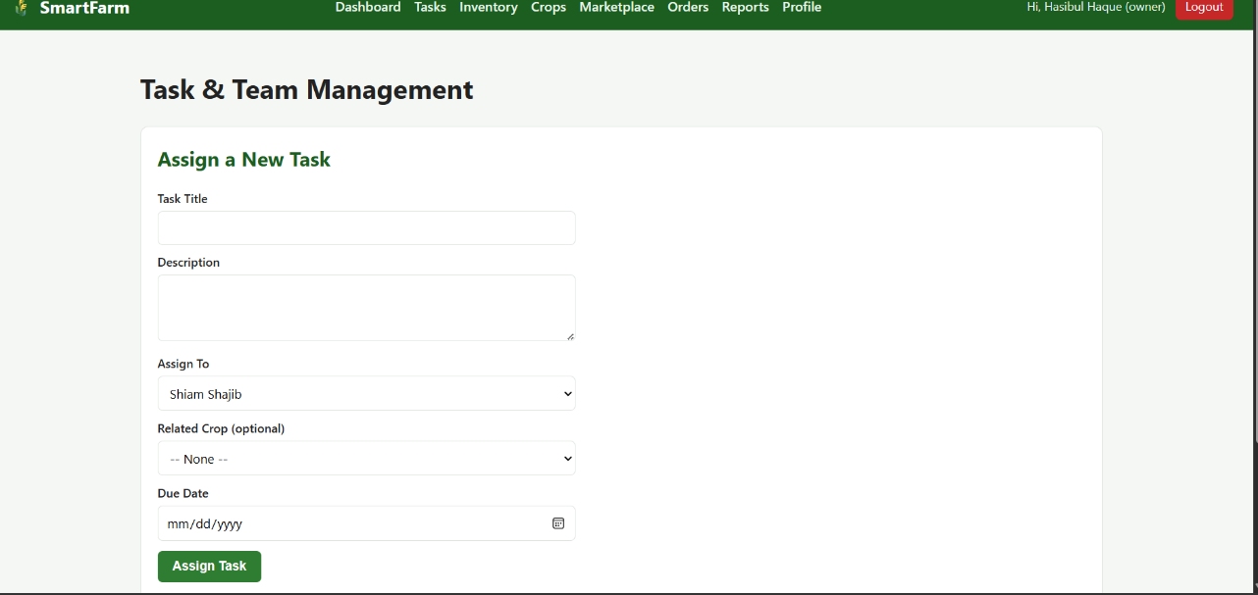
Fig 3: dashboard
.
Types of User: 1. Farm Owner 2. Farm Worker 3. Buyer
Common Features (Available to All Users)
Authentication
- Login to the system
- Logout from the system
- User registration
Account Management
- Change or reset password
- Manage profile information (view, edit, delete)
Dashboard
- Access a personalized dashboard after login

Specific Features by User Type

Features of Farm Owner (User1)
- Task & Team Management: Create daily tasks with specific descriptions and assign them directly to farm workers.
- Inventory Oversight: Manage all inventory items, including categorizing supplies and tracking exact stock quantities to trigger low-stock alerts.
- Analytics & Marketplace: Generate detailed financial and yield reports, and manage the products listed in the marketplace by setting prices and available stock.

Features of Farm Worker (User2)
- Task Execution: View daily tasks assigned by the administrator and update the task status as work progresses in the field.
- Field Data Logging: Input vital field data, which includes recording entry dates, linking data to specific crops/livestock, and adding observational notes on health.
- Harvest Recording: Record specific harvest data including the quantity, date, and quality grade for crops.

Features of Buyer (User3)
- Marketplace Navigation: Browse available farm produce, viewing product names, prices, and available stock quantities directly from the farm.
- Order Management: Place orders by adding specific quantities of products and make secure online payments selecting a preferred payment method.
- Delivery Tracking: Track the real-time status of their placed deliveries using designated tracking information.

